Software Requirements and Specifications

Pakistan Super League Drafting Application

Version 1.0 approved

Prepared by:

Muhammad Jawad Khan (FA20-BSE-068)

Sohaib Arif (FA20-BSE-051)

Ihtesham Ali (FA20-BSE-060)

Muhammad Umair (FA20-BSE-055)

CUI Wah 20/06/2022

|  |  |  |  |
| --- | --- | --- | --- |
| Revision History | | | |
| Date | Revision | Description | Author |
| 18/12/2022 | 1.0 | Initial Revision | Muhammad Umair  Muhammad Sohaib  Ihtesham Ali  Muhammad jawad |
|  |  |  |  |
|  |  |  |  |
|  |  |  |  |

# Introduction

## Purpose

## The main objective of our PSL Drafting Application is to provide ease to franchises for selecting players without any formal gathering. It will be a one clicks solution to manage a mega cricket event.

## Intended Audience and Reading Suggestions

The intended audience is the PCB, PSL related franchises and players

## Product Scope

This project is mainly developed for official use of PCB. This is a first ever PSL based application in which we can select the players of different franchises and make a squad. Instead of organizing a drafting event, franchise owners will be given access of players details by PCB in PSLDA application.

Definitions, Acronyms, and Abbreviations:

Drafting: Drafting is a process of selecting players by each franchise to make squad.

PSDA: Pakistan Super League Drafting Application

PCB: Pakistan Cricket Board

## References

REF-1 URL” <https://stats.espncricinfo.com/ci/engine/records/index.html?id=7;type=team>”

REF-2 URL” <https://en.wikipedia.org/wiki/Pakistan_Super_League>”

# Overall Description

## Product Perspective

This management system can make PSL happen with strict rules and regulations even in situations like Covid’19 or terrorism attacks or many more. So, it has a great importance in market because it can manage a mega event on which our country’s reputation would be based and it would also be a source of income through which we can make our country’s economy stronger.

## Product Functions

* Drafting
* User Login/ Registration

## User Classes and Characteristics

There are 3 classes of this management system: PCB, Franchises and Players.

The characteristics of the PCB class are login, Chat box, Rules. The characteristics of

Franchise class are login, drafting rules, drafting. The characteristics of Player class are login, player statistics, pitch report, matches schedule and chat box.

## Operating Environment

The operating environment for PSLMS would be Windows 10, JAVA (NetBeans 8.2) and JDK 11

## Design and Implementation Constraints

Language: Java

Tools: NetBeans, MySQL, photoshop.

## User Interfaces:

## User Documentation

* Tutorials will be provided to use PSLMS
* A manual about the system will also be provided.

## Assumptions and Dependencies

In the scenario of over management systems, I think internet will affect the working of our system

and will give bad impact to the users so they should have proper internet connection for this

management system.

# Use Case Model Survey: -

|  |  |
| --- | --- |
| **Use Case Id and Name** | 01, Player Statistics |
| **Created By** | Muhammad Umair  **Date Created: 11/30/2022** |
| **Description** | * Player will first login into the system * Player will then click on player statistics. * Player will enter his shirt number and click on enter button. * Player current stats would be shown to him. * At end player will logout from the system. |
| **Trigger** | players enter his shirt number. |
| **Pre-Condition** | PRE-1 player has to login into the system by entering correct username and password.  PRE-2 Player will enter into the player stats section to show his stats. |
| **Post-Condition** | POST-1 After player enters his shirt number his stats would be shown to him.  POST-2 All the data shown to is always stored in database. |
| **Normal Flow** | 1. Player will login into the system known as PSLDA. 2. Then player will login into his module to reach his dashboard. 3. From dashboard player click on player statistics. 4. After that player will enter his shirt number. 5. Player will press the enter button and his stats would be shown to him. |
| **Alternative Flow** | 1. Player can’t be able to login into system. 2. Player can’t be able to login into his module. 3. Player can’t enter his correct shirt number |
| **Exceptions** | 1. Incorrect username and password 2. Invalid shirt number. 3. System issue 4. Player stats are nor up to date. |
| **Priority** | High |
| **Frequency Of Use** | Depends upon no the use of players. |
| **Business Rules** | N/A |
| **Other Information** | N/A |
| **Assumptions** | N/A |

# Actor Survey: -

|  |  |
| --- | --- |
| Actor Info | |
| Actor Name | Description |
| Player | Players is one of the actors of our system who have the access to see his stats through his shirt number. Player shall see the matches schedule and pitch report. |
| Franchise | Franchise is our 2nd actor of our system who have the responsibility to select the players based on their performance and make their respective teams. Each franchise would select 15 players. There are 6 franchises listed below:   1. Islamabad United 2. Lahore Qalandar 3. Multan Sultan 4. Peshawar Zalmi 5. Quetta Gladiator 6. Karachi Kings |
| PCB | Our 3rd actor of the system is the PCB, which is the admin of the system. PCB gives the rules and regulations for drafting and for Pakistan super league. PCB also have access to edit the players stats and pitch report. |

# Functional Requirements: -

System Login: -

FR 201 User will enter correct username and password.

FR 202 If wrong username and password would be entered error message would be Generated.

FR 203 Correct login will lead to the dashboard.

Dashboard:

There are 3 main modules:

1. Player (User)
2. Franchise (Owner)
3. PCB (Admin)

Player: -

FR 204 Player will login by entering correct username and password.

FR 204 Correct login leads to player dashboard.

FR 205 Player dashboard contains player statistics, pitch report and matches schedule.

FR 206 In player statistics player should enter his shirt number to show his stats.

FR 207 In pitch report, player enter the match number and pitch report would be generated.

FR 208 By clicking on matches schedule, whole schedule of matches would be shown.

FR 209 Player will logout out by clicking on the logout button.

Franchise: -

FR 301 Franchise will login by entering correct username and password.

FR 302 Correct login leads to Franchise dashboard.

FR 303Franchise dashboard contains drafting rules and start drafting button.

FR 304 By clicking on drafting button drafting would be started.

FR 305 Franchise would be given 5 categorize to select the player (Platinum, Diamond, Gold, Silver, and emerging players.)

FR 306 Each franchise would be given 3 minutes to select the players from each category.

FR 307 Franchise is restricted to select 15 players for their franchise.

FR 308 After selecting players, it will make a squad for each franchise.

FR 309 By clicking on Squad button franchise will see their squad.

FR 310 Franchise will logout out by clicking on the logout button.

PCB: -

FR 3011 PCB will login by entering correct username and password.

FR 312 Correct login leads to PCB dashboard.

FR 313 PCB dashboard contains rules and regulation of PSL, edit player statistics and edit pitch report.

FR 314 PCB add new rules in the application

FR 315 PCB update and add players statistics.

FR 316 PCB update and add pitch details (weather, pitch condition, Due factor, pitch type)

FR 317 PCB will logout out by clicking on the logout button.

# Non-functional Requirements

## Safety Requirements

NFR 401 We will apply validation to prevent invalid users from entering our application.

## Security Requirements

NFR 402 We will use latest technology and strong system login that will allow only official users like players, franchise, and PCB.

Other Non-functional Requirements:

NFR 403 Chat box player to send their problems to PCB.

NFR 404 Chat box for franchise to send their issues to PCB.

NFR 405 Chat box for PCB to receive the problems send by players and franchises and send them their solutions.

## Software Quality Attributes

* Accessible
* Aesthetics
* Cost-effective
* Functional/operational
* Productive
* Secure/safe
* Sustainable.
* Green Field Engineering

## Business Requirements

# BR 101 This application mainly give benefit to PCB in a way that it will reduce the cost and time.

BR 102 The foreign person that will come to Pakistan for drafting will now stay at home and participate in drafting and do their work.

BR 103 This application makes the drafting possible in difficult situations like Covid’19 that will help to conduct the PSL on time and this will ultimately give benefit to players, franchises, PCB, and our country as well.

## Purchased Components:

No purchased components.

## Software Interfaces:

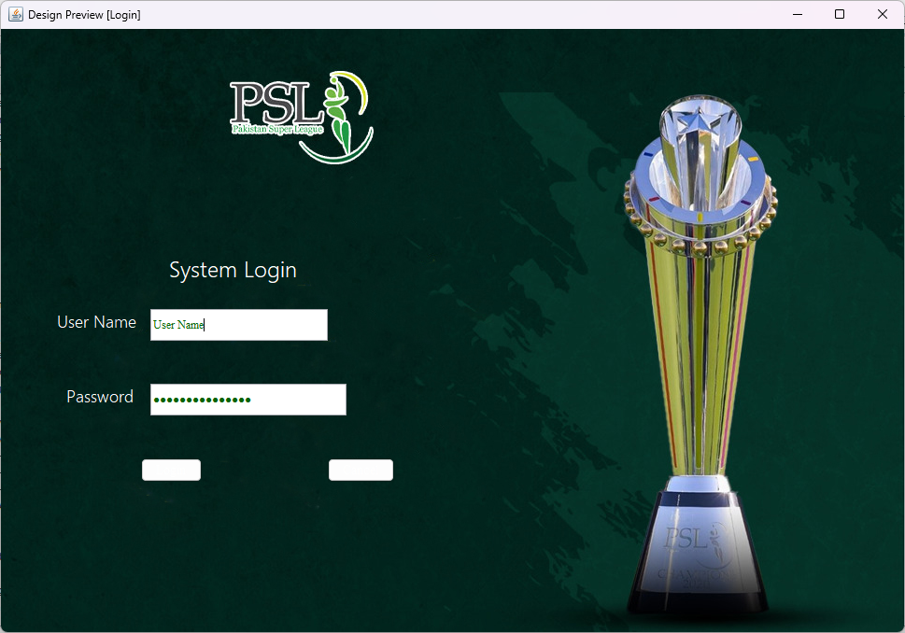

# 

# 

# 

# 

# 

# Licensing and Security Requirements:

As this application is approved by government organization (PCB) so PCB give the licence of this application to all the users.

The security requirement is We will apply validation to prevent invalid users from entering our application.

Legal, Copyright, and Other Notices:

If player and franchise don’t follow the rules and regulations notice would be taken against them and fines would be imposed to them.

Applicable Standards:

IEEE would be used as a standard.

Index:

Glossary:

Appendixes:

# Design Description:

Class Diagram:

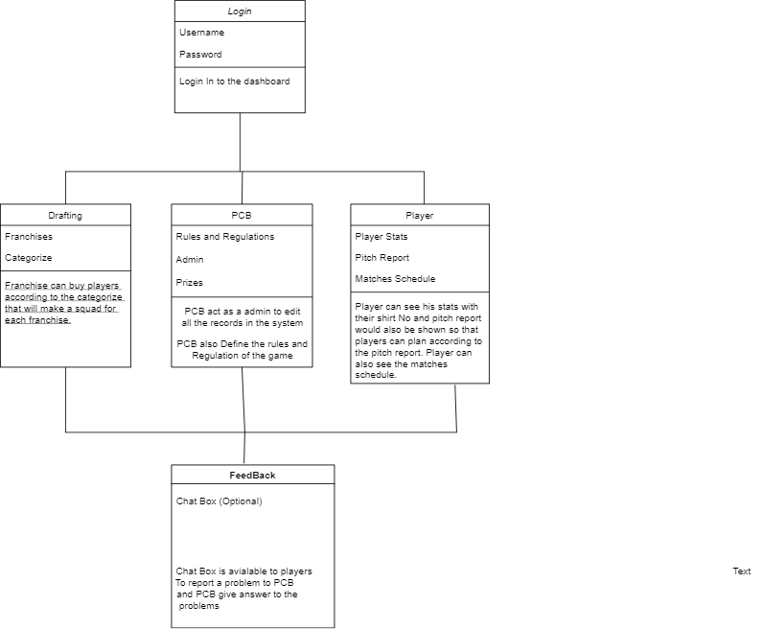

**Decision Trees:**

Player Module:

Enter Shirt No

Do Nothing

Show Pitch Report

Do Nothing

Enter Match Date

Show Player Stats

Matches Schedule

Pitch Report

Player Statistics

Do Nothing

Dashboard

Players Login

YES No

Yes No Yes No

Drafting Module:

2 min time to select Players

Categorize Selection

Do Nothing

Emerging Players

Silver

Gold

Diamond

Drafting Rules

Start Drafting

Do Nothing

Dashboard

Franchise Login

YesNo

Platinum

Yes, Yes Yes Yes Yes

Squad

PCB Module: -

PCB Login

Rules and Regulation

Incorrect Info

Enter Correct Info

Incorrect Details

Enter Correct Details

Edit Pitch Report

Edit Player Stats

Dashboard

Do Nothing

YES NO

**Y**ES NO YES NO

**State Chart:**

**Flow Chart Diagram:**

ER Diagram:

